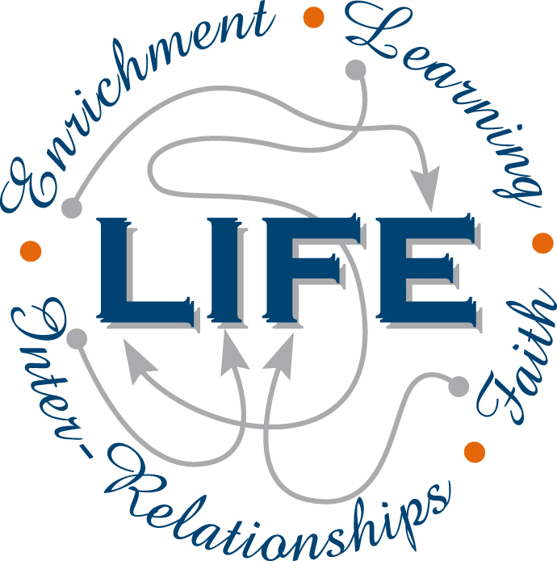
Holy Cross College

Semester 1 Examination 2012

Question/Answer Booklet

Year 10 Science
Please place your student identification label in this box
(Modified)

Student Name
Student’s Teacher

Time allowed for this paper

Reading time before commencing work: 10 minutes
Working time for paper: 90 minutes

Materials required/recommended for this paper

To be provided by the supervisor

This Question/Answer Booklet
Data Sheet

To be provided by the candidate

Standard items: pens, pencils, eraser, correction fluid, ruler, highlighters.
Special items: non-programmable calculators satisfying the conditions set by the School Curriculum and Standards Authority for this course.

Important note to candidates

No other items may be taken into the examination room. It is your responsibility to ensure that you do not have any unauthorised notes or other items of a non-personal nature in the examination room. If you have any unauthorised material with you, hand it to the supervisor before reading any further.

Structure of this paper

Section | Number of questions available | Number of questions to be answered | Suggested working time  (minutes) | Marks available | Percentage of exam
Section One:  Multiple Choice | 40 | 40 | 30 | 40 | 31
Section Two:  Short Answer | 13 | 13 | 45 | 81 | 62
Section Three:  Comprehension | 1 | 1 | 15 | 10 | 7
 |  |  |  | 131 | 100

Instructions to candidates

1. The rules for the conduct of examinations at Holy Cross College are detailed in the College
Examination Policy. Sitting this examination implies that you agree to abide by these rules.

2. Write your answers in this Question/Answer Booklet.

3. Working or reasoning should be clearly shown when calculating or estimating answers.

4. You must be careful to confine your responses to the specific questions asked and to follow
any instructions that are specific to a particular question.

5. Spare pages are included at the end of this booklet. They can be used for planning your
responses and/or as additional space if required to continue an answer.

• Planning: If you use the spare pages for planning, indicate this clearly at the top of the
page.
• Continuing an answer: If you need to use the space to continue an answer, indicate in
the original answer space where the answer is continued, i.e. give the page number.
Fill in the number of the question(s) that you are continuing to answer at the top of the
page.

Achievement Standards

The transmission of heritable characteristics from one generation to the next involves DNA and genes.

The atomic structure and properties of elements are used to organise them in the Periodic Table.
SECTION 1 MULTIPLE CHOICE (40 marks)

Choose the best answer for each question in the Multiple Choice Question booklet.

Mark your selection with a cross.

1 | (a) | (b) | (c) | (d) |  | 26 | (a) | (b) | (c) | (d)
2 | (a) | (b) | (c) | (d) |  | 27 | (a) | (b) | (c) | (d)
3 | (a) | (b) | (c) | (d) |  | 28 | (a) | (b) | (c) | (d)
4 | (a) | (b) | (c) | (d) |  | 29 | (a) | (b) | (c) | (d)
5 | (a) | (b) | (c) | (d) |  | 30 | (a) | (b) | (c) | (d)
6 | (a) | (b) | (c) | (d) |  | 31 | (a) | (b) | (c) | (d)
7 | (a) | (b) | (c) | (d) |  | 32 | (a) | (b) | (c) | (d)
8 | (a) | (b) | (c) | (d) |  | 33 | (a) | (b) | (c) | (d)
9 | (a) | (b) | (c) | (d) |  | 34 | (a) | (b) | (c) | (d)
10 | (a) | (b) | (c) | (d) |  | 35 | (a) | (b) | (c) | (d)
11 | (a) | (b) | (c) | (d) |  | 36 | (a) | (b) | (c) | (d)
12 | (a) | (b) | (c) | (d) |  | 37 | (a) | (b) | (c) | (d)
13 | (a) | (b) | (c) | (d) |  | 38 | (a) | (b) | (c) | (d)
14 | (a) | (b) | (c) | (d) |  | 39 | (a) | (b) | (c) | (d)
15 | (a) | (b) | (c) | (d) |  | 40 | (a) | (b) | (c) | (d)
16 | (a) | (b) | (c) | (d)
17 | (a) | (b) | (c) | (d)
18 | (a) | (b) | (c) | (d)
19 | (a) | (b) | (c) | (d)
20 | (a) | (b) | (c) | (d)
21 | (a) | (b) | (c) | (d)
22 | (a) | (b) | (c) | (d)
23 | (a) | (b) | (c) | (d)
24 | (a) | (b) | (c) | (d)
25 | (a) | (b) | (c) | (d)

SECTION 2 SHORT ANSWER (81 marks)

Attempt all questions. Write your answers in the spaces provided.

1. In the table below, choose the correct statement for each word given. Write the letter of the correct statement next to the word.

WORD | CORRECT  LETTER | STATEMENT
dominant |  | A - how an organism looks due to its genes.
genotype |  | B - hides the other gene in a pair (e.g. T).
gamete |  | C - see a new characteristic in an organism.
phenotype |  | D - same genes in a pair (e.g. TT, tt).
pure-bred |  | E - gene that is hidden by another gene (e.g. t).
incomplete dominance |  | F - the genes for a particular characteristic.
hybrid |  | G - sex cell of an organism.
recessive |  | H - different genes in a pair (e.g. Tt)

(8 marks)

2. Complete the table below for the parts of the cell as shown in the diagram below. Choose the
correct number for the name of the part.

Choose from the following names - not all parts are shown in the diagram.

Nucleus Cell Membrane Cell Wall Nucleolus
Ribosome Mitochondria Endoplasmic Reticulum Golgi Complex Vesicles Centrioles Cytoplasm
Number | Name
1
2
3
4
5
6
(small dot)
1
2
4
5
6
3

(6 marks)
3. In the table below, choose the correct statement for each part of a cell. Write the letter of the correct statement next to the word.

CELL PART | CORRECT  LETTER | STATEMENT
centriole |  | A - produces protein for the cell.
mitochondria |  | B - controls all cell functions and contains DNA.
cell membrane |  | C - produces spindle fibres.
nucleus |  | D - produces energy for the cell
ribosome |  | E - provides strength for plant cells.
cell wall |  | F - allows food and oxygen into a cell and wastes out.

(6 marks)

4. Carefully examine the photo of a young animal (centre) showing the genetic condition called
albinism.

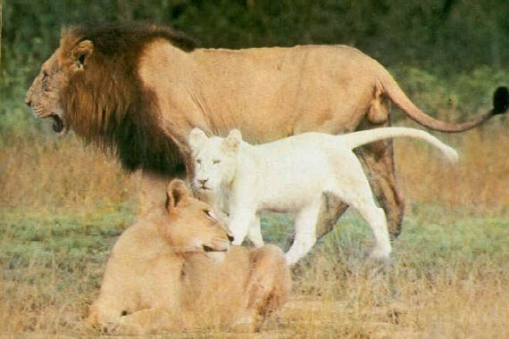

(a) Describe the phenotype of an animal with albinism.

(1 mark)

(b) The young lion cub inherits all its features from its parents. As you can see in the
picture, the lion cub shows the condition but neither of its parents (the male and female
lions in the picture) is albino.

Suggest one reason that explains why the phenotype for albinism seen in the lion cub is
not visible in either of the lions parents.

(1 mark)

5. The pedigree below shows the occurrence of polydactyly (more fingers or toes than normal)
in three generations of a family.

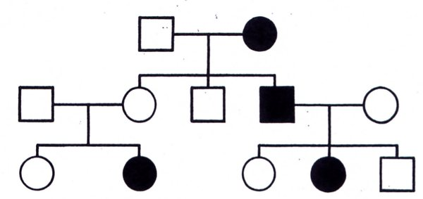

(a) How many people in total show the disorder in this family?
(1 mark)

(b) How many people with the disorder are female?
(1 mark)

(c) Is this a dominant or a recessive trait? Explain your answer.
(Circle the part of the pedigree you are considering in your answer.)

(2 marks)

(b) Determine the genotypes of the individuals in the pedigree. (Remember to work from
the bottom up.)

Write the genotypes neatly and clearly on the diagram.

If the second allele can't be determined, use a blank space.

e.g. A_ or T_ (depending on the letter you choose).

(4 marks)

5. In guinea pigs, rough coat (R) is dominant to smooth coat (r). Two hybrid rough coated
guinea pigs (Rr) are mated. Determine the genotype and phenotype of the possible offspring.
Include percentages to show the probabilities. Show all of your working.

Parents:

Genotype:

Phenotype:

Percentages:

(5 marks)

6. In snapdragon flowers, red colour (RR) is incompletely dominant to white colour (WW).
Hybrid plants produce pink flowers (RW).

(a) Two hybrid pink flowered plants are crossed. Show the possible genotype and
phenotype of their offspring.

Parents:

Genotype:

Phenotype:

(4 marks)

(b) In some plants, flowers show co-dominance. For example, crossing a red flower with a
white flower produces red flowers with white parts, or vice versa.

Explain how co-dominance is different to incomplete dominance.

(2 marks)
7. (a) Next to each phase of mitosis, write down the name of the phase and a brief description
to explain what is occurring.

You can choose from the following, though not all stages are mentioned.

metaphase telophase interphase anaphase prophase
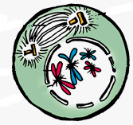
Name:

Description:

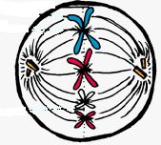
Name:

Description:

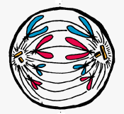

Name:

Description:

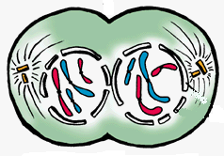

Name:

Description:

(8 marks)
(b) What is the purpose of mitosis in the human body?

(1 mark)

(c) Which cells of the body undergo mitosis?

(1 mark)
8. (a) Who determines the sex of any children born into a family - the father (XY) or
mother (XX)? Give a reason for your answer.

(2 marks)

(b) A family has three girls born over five years and the mother is pregnant with a fourth
child. What is the chance of the unborn child being a female?

Justify your answer by setting out a genetics calculation using a Punnett square.

Parents:

Genotype:

Phenotype:

Percentages: (4 marks)

9. In the table below, choose the correct meaning for each word given. Write the letter of the
correct meaning next to the word.

WORD | CORRECT  LETTER | MEANINGS
neutron |  | A - a row of the periodic table.
period |  | B - building block of matter.
molecule |  | C - two or more elements chemically combined.
compound |  | D - two or more atoms chemically combined.
group |  | E - column of the periodic table.
atom |  | F - particle with no charge.

(6 marks)

10. Complete the following table, using the periodic table to assist.

Symbol | Number of Protons | Number of Neutrons | Number of Electrons
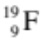
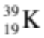
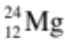

(3 marks)

11. Draw the electron configuration diagrams for the following elements. Remember to include
the particles in the nucleus.

(i) 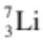 (ii) 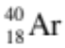

(4 marks)

12. Classify the following elements as alkali metals, transition metals, metalloid (semi-metals),
or halogens or noble (inert) gases.

Xe Te Cs Mn F Li I Ne Na Ni Ge Hg

Halogen | Noble (Inert) Gas | Alkali metal | Transition Metal | Metalloid  (Semi-Metal)
(6 marks)

13. Write the symbols or names for the following elements.

ELEMENT | SYMBOL
chlorine
potassium
gold
argon
manganese
 | Zn
 | Ca
 | W
 | Sn
 | B
(5 marks)
SECTION 3 COMPREHENSION (10 marks)

Read the article and then answer the questions that follow. Write your answers in the spaces provided.

Many scientists contributed to the development of the Periodic Table. The tables below summarise some information about them.

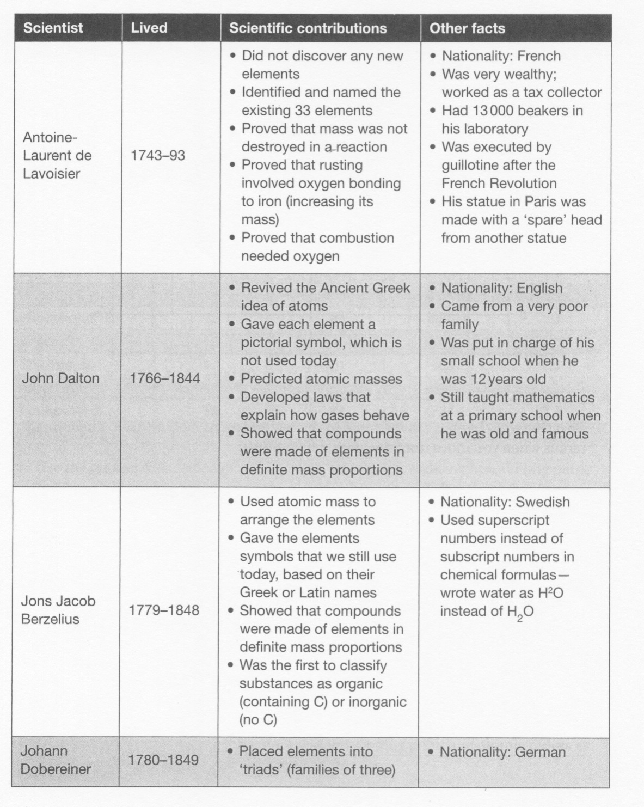

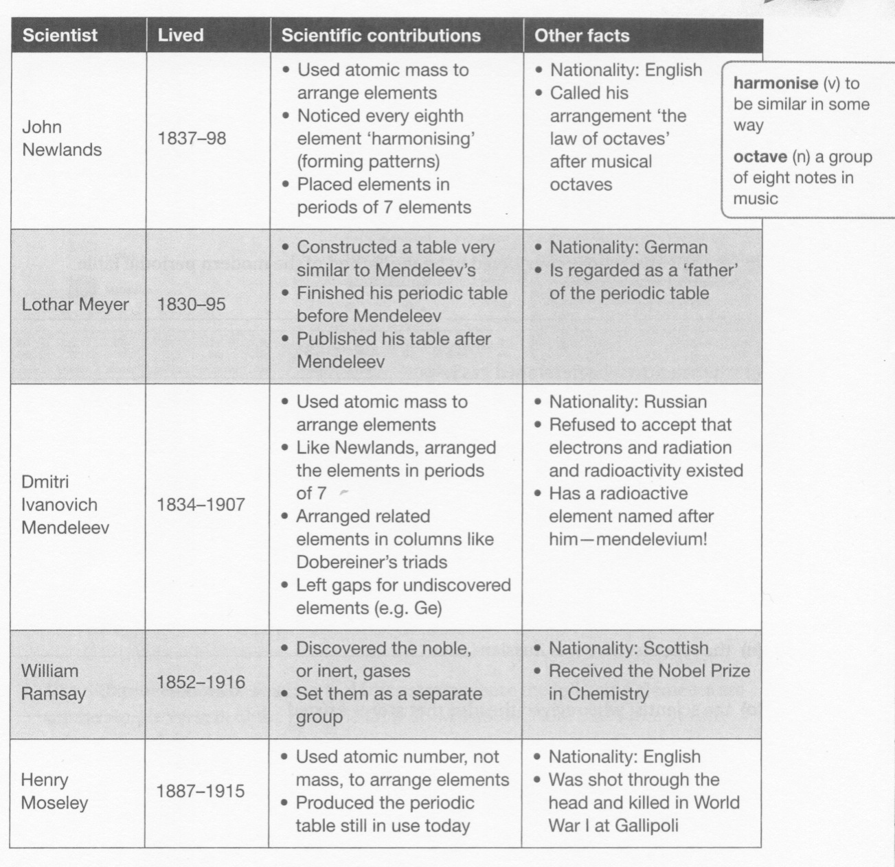

Use the information in the tables to answer the following questions.

1. Which scientist were:

• Scottish?

• Swedish?

• French?
(3 marks)

2. Who received a Nobel Prize and for which branch of science?

(2 marks)
3. Name the scientists that did the following:

• Developed the gas laws.

• Left gaps in his table.

• Developed the idea of "triads".

• Proved that iron got heavier as it rusted.

• Showed that compounds were made of elements in
definite mass proportions.

(5 marks)

END OF EXAMINATION

THIS PAGE HAS BEEN DELIBERATELY LEFT BLANK.

THIS PAGE HAS BEEN DELIBERATELY LEFT BLANK.

